
Paper Title (Arial, 17, Line Height 1)
ARTICLE

Journal of
Sensor Science and Technology

Name¹, Name¹, and Name^{2,+} (Times New Roman, 12, Line Height 1)

¹ School of Electrical Engineering, Seoul National Unversity, SoEECS 301-1014, 599 Gwanangno, Gwanak-gu, Seoul, 03080, Korea
² Department of Integrated Systems Engineering, Hankyong National University, 327 Jungang–ro, Anseong, 03080, Korea

Cite This: J. Sens. Sci. Technol. xxxx, xx, x, xxxx-xxxx https://doi.org/10.46670/JSST.xxxx.xx.xx.

ABSTRACT: Please put the abstract of here.(Times New Roman, 10, Line Height 1)
The number of abstract should be in the range of 150 words ~ 200 words.

KEYWORDS: Gas sensors, Oxide semiconductors, SnO2, Propane gas (Times New Roman, 10, Line Height 1)

1. INTRODUCTION(Times New Roman, 12, Line Height 1)

Write introduction here.(Times New Roman, 10, Line Height 1)

2. EXPERIMENTAL(Times New Roman, 12, Line Height 1)

2.1 Title(Times New Roman, 10, Line Height 1)

Write content here.(Times New Roman, 10, Line Height 1)

2.1.1 Title(Times New Roman, 10, Line Height 1)
Write design here.(Times New Roman, 10, Line Height 1)

3. RESULTS AND DISCUSSIONS(Times New Roman, 12, Line Height 1)
⁺Corresponding author: name@snu.ac.kr
Received : Feb. 2, 2025, Revised : Feb. 12, 2025, Accepted : Feb. 22, 2025

This is an Open Access article distributed under the terms of the Creative Commons Attribution Non-Commercial License (https://creativecommons.org/licenses/by-nc/3.0/) which permits unrestricted non-commercial use, distribution, and reproduction in any medium, provided the original work is properly cited.

3.1 (Times New Roman, 10, Line Height 1)

Write content here. (Times New Roman, 10, Line Height 1)

3.1.1 Title(Times New Roman, 10, Line Height 1)

Write result and discussion here. (Times New Roman, 10, Line Height 1)

Put the number at the end of the equation.

(1)

Table 1. Please put the title of table here.(Times New Roman, 10, Line Height 1)
All the contents in table should be given in English.
item1 | item2 | item3

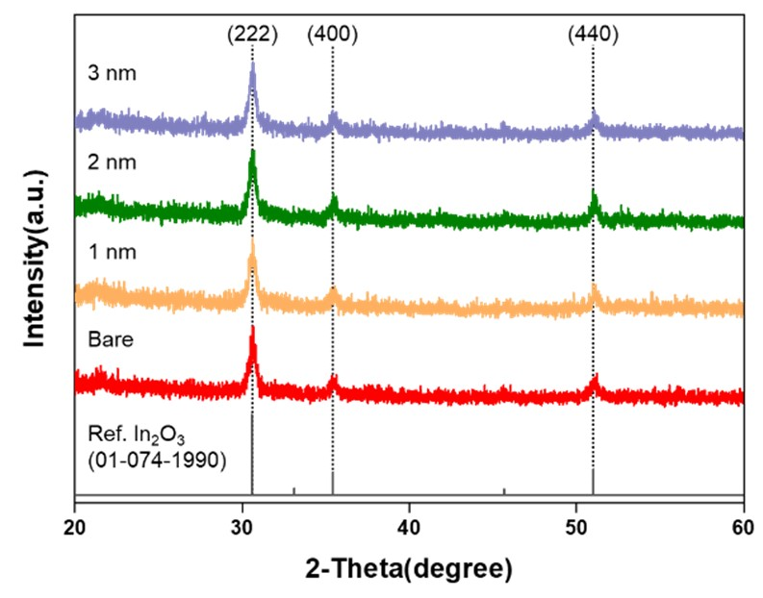
Fig. 1. Please put the title of figure here. (Times New Roman, 10, Line Height 1)

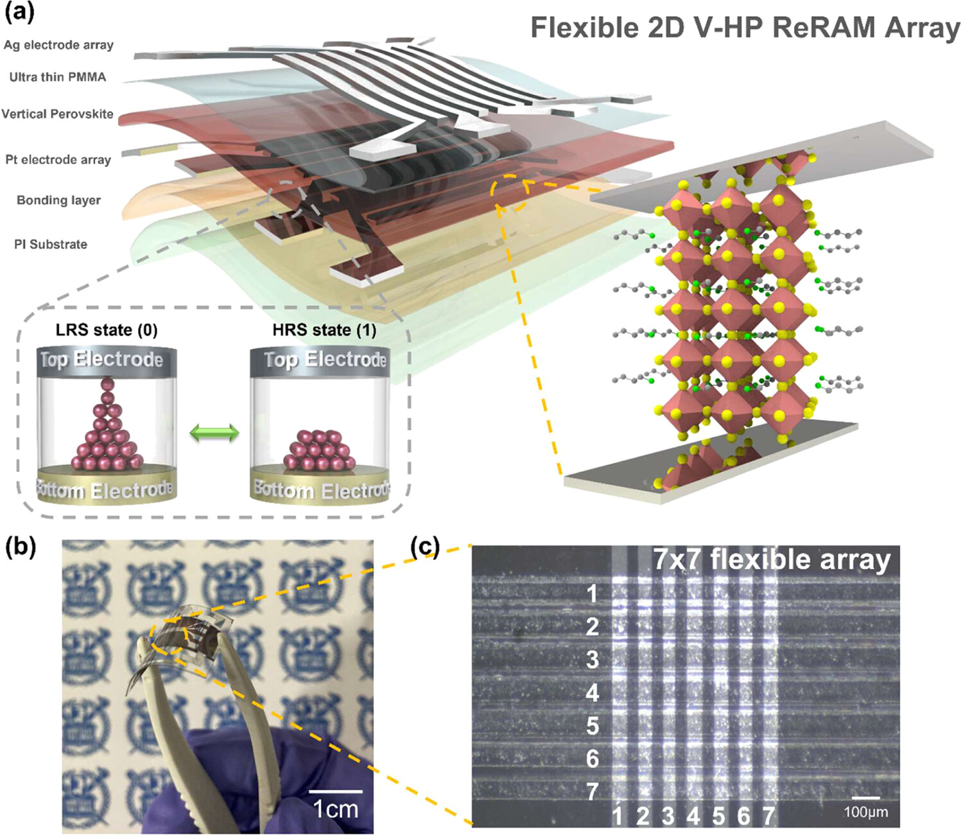
Fig. 2. Please put the title of figure here ; (a) Aaa, (b) Bbb, (c) Ccc, and (d) Ddd. Adapted from Ref. [XX].

*Note: Figure Caption Guidelines
-Each figure must have a caption placed below the figure.
-Figures should be numbered consecutively in the order they appear in the text (e.g., Fig. 1., Fig. 2., …).
- Captions must always include a title describing the figure.
- Panel labels within a figure should be indicated as (a), (b), (c), (d), … .
-When figures are reproduced or adapted from other sources, the following format should be used and the source must be included in the reference list: Adapted from Ref. [XX].

4. CONCLUSIONS (Times New Roman, 12, Line Height 1)

Write conclusion here.(Times New Roman, 10, Line Height 1)

Write CRediT Authorship Contribution Statement, Declaration of Competing Interest, Acknowledgments, ORCID and Additional information here. (Time New Roman, 10, Line Height 1)

CRediT Authorship Contribution Statement
Corresponding authors are required to acknowledge co-author contributions using CRediT (Contributor Roles Taxonomy) roles:

-Conceptualization
-Data curation
-Formal analysis
-Funding acquisition
-Investigation
-Methodology
-Project administration
-Resources
-Software
-Supervision
-Validation
-Visualization
-Writing – original draft
-Writing – review and editing

[Example]
Tingting He: Investigation, Methodology, Writing - original draft. Wei Liu: Validation. Tan Lv: Funding acquisition. Mingsheng Ma: Writing - review & editing, Supervision. Zhifu Liu: Writing - review & editing, Supervision. Alexey Vasiliev: Supervision. Xiaogan Li: Writing - review & editing, Supervision, Funding acquisition.

Declaration of Competing Interest
All authors must disclose any financial and personal relationships with other people or organizations that could inappropriately influence or bias their work.

If you don't have a declaration of competing Interest, it is recommended to include the following sentence:
The authors declare that they have no known competing financial interests or personal relationships that could have appeared to influence the work reported in this paper.

Acknowledgements
Authors must disclose any funding sources who provided financial support for the conduct of the research and/or preparation of the article.

If no funding has been provided for the research, it is recommended to include the following sentence:
This research received no external funding.

ORCID
Please list any authors who have ORCIDs.
Gil Dong Hong: https://orcid.org/0000-0000-1234-1234

REFERENCES(TIME NEW ROMAN, 12, LINE HEIGHT 1)

Write references here. (Time New Roman, 10, Line Height) All references should be given in English.

a journal publication
Format:
[1] Author, Title of article, Abbreviated Journal Title. Volume (Year) Page range.

Example:
[1] J. van der Geer, T. Handgraaf, R.A. Lupton, The art of writing a scientific article, J. Sci. Commun. 163 (2020) 51–59.

a journal publication with an article number
Format:
[1] Author, Title of article, Abbreviated Journal Title Volume (Year) article number.

Example:
[1] J. van der Geer, T. Handgraaf, R.A. Lupton, The art of writing a scientific article, Heliyon 19 (2022) e00205.

a Conference Paper
Format:
[1] Author, Title of paper, Proceedings of the [Title of conference], City, Country, Year, pp. page numbers.

Example:
[1] J. Yan, H. Dong, X. Zhang, J. Zhao, A three-chambed soft actuator module with omnidirectional bending motion, Proceedings of the IEEE International Conference on Real-time Computing and Robotics, Munich, Germany, 1993, pp. 281–304.

a book
Format:
[1] Author, Title of book, #ed, Publisher, Place of publication, Year.

Example:
[1] W. Strunk Jr., E.B. White, The Elements of Style, fourth ed., Longman, New York, 2000.

a chapter in a book
Format:
[1] Author of chapter, Title of chapter, In: Editor(s) (Eds.), Title of book, Publisher, Place of publication, Year, pp. page numbers of the chapter.

Example:
[1] G.R. Mettam, L.B. Adams, How to prepare an electronic version of your article, In: B.S. Jones, R.Z. Smith (Eds.), Introduction to the Electronic Age, E-Publishing Inc., New York, 2020, pp. 281–304.

a website
Format:
[1] Author or Organisation, Title of the webpage.
URL, Year (accessed Day Month Year).

Example:
[1] Cancer Research UK, Cancer statistics reports for the UK. http://www.cancerresearchuk.org/aboutcancer/statistics/cancerstatsreport/, 2023 (accessed 13 March 2023).

Thesis or dissertation
Format:
[1] Author, Title of the Thesis/Dissertation, Degree type, University, City, Country, Day Month Year.

Example:
[1] J. Ramirez-Salgado, Contribution à l’étude des électrodes à gaz dans un capteur potentiométrique à CO2 de deuxième espèce, Ph.D. thesis, Université J. Fourier, Grenoble, France, 20th September 2001.

Patents
Format:
[1] Inventor, Title of patent, Country patent number (Date issued)

Example:
[1] P.M. Typpo, H2S measuring systems and the like, U.S. Patent 4 432 224 (1984)

Preprint
Format:
[1] Author, Title of the preprint, Preprint server name, DOI or URL (Year)

Example:
[1] F. Kotz, P. Risch, K. Arnold, A. Quick, M. Thiel, A. Hrynevich, P.D. Dalton, D. Helmer, B.E. Rapp, Sacrificial Template Replication: fabrication of arbitrary three-dimensional suspended hollow microstructures in transparent fused silica glass, ArXiv., https://arxiv.org/abs/1807.09054 (2018)

<Notes>
For journal abbreviations, see the site
1.https://www.ncbi.nlm.nih.gov/nlmcatalog/journals
2.http://www.issn.org/services/online-services/access-to-the-ltwa/

