Paper Title (Times New Roman, 14, Line Height 1)

Abstract(Times New Roman, 11, Line Height 1)

Please put the abstract of here.(Times New Roman, 10, Line Height 1)
The number of abstract should be in the range of 150 words ~ 200 words.

Keywords : Gas sensors, Oxide semiconductors, SnO₂, Propane gas (Times New Roman, 10, Line Height 1)

INTRODUCTION (Times New Roman, 12, Line Height 1)

Write introduction here.(Times New Roman, 10, Line Height 1)

EXPERIMENTAL (Times New Roman, 12, Line Height 1)

2.1 Title(Times New Roman, 10, Line Height 1)

Write content here.(Times New Roman, 10, Line Height 1)

2.1.1 Title(Times New Roman, 10, Line Height 1)
Write design here.(Times New Roman, 10, Line Height 1)

RESULTS AND DISCUSSIONS(Times New Roman, 12, Line Height 1)

3.1 (Times New Roman, 10, Line Height 1)

Write content here. (Times New Roman, 10, Line Height 1)

3.1.1 Title
Write result and discussion here. (Times New Roman, 10, Line Height 1)

Put the number at the end of the equation.

$\begin{aligned}\int{ F(r,ϕ)} \text{dr} dϕ=[{σr}_{2} (2μ_{0})] \\ ⋅ \int{ \text{exp}}(−λ|z_{j}−z_{i}| ) λ^{−1} J_{1}(λ r_{2}) J_{0}(λ r_{i}) dλ \text{.}\end{aligned}$(1)

Table 1. Please put the title of table here.(Times New Roman, 10, Line Height 1)
All the contents in table should be given in English.
item1 | item2 | item3

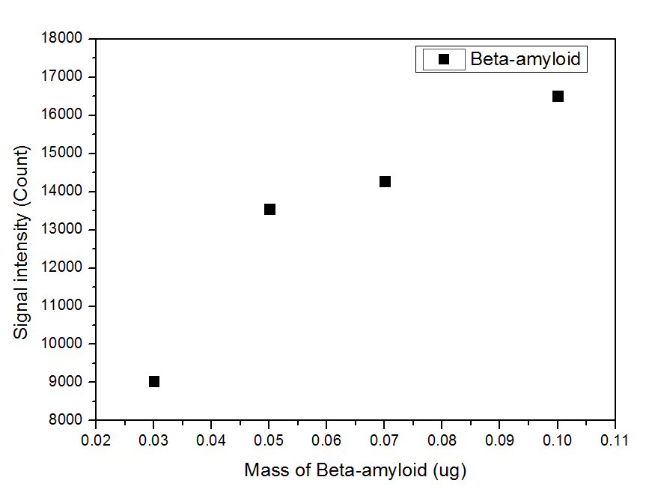
Fig. 1. Please put the title of figure here.(Times New Roman, 10, Line Height 1)

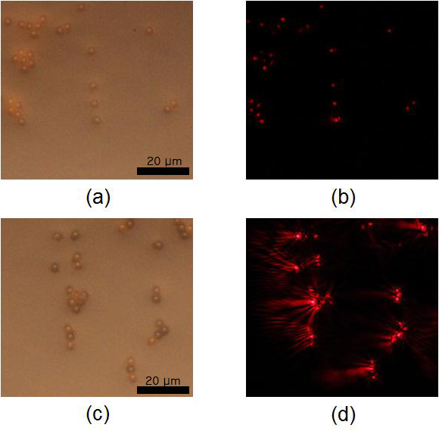
Fig. 2. Please put the title of figure here ; (a) Aaa, (b) Bbb, (c) Ccc, (d) Ddd.

CONCLUSIONS(Times New Roman, 12, Line Height 1)

Write conclusion here.(Times New Roman, 10, Line Height 1)

ACKNOWLEDGMENT(Times New Roman, 12, Line Height 1)

Write acknowledgment here.(Time New Roman, 10, Line Height 1)

REFERENCES(Time New Roman, 12, Line Height 1)

Write references here.(Time New Roman, 10, Line Height) 1) All references should be given in English.

A. In the case of journals: Names of the authors, “title”, name of the journal in italic type(ISO Abbrev. Title), volume number, page numbers and year published.

[1] T. Takalokastari, S. J. Jung, D. D. Lee, and W. Y. Chung, “Real time drowsiness detection by WSN based wearable ECG measurement system”, J. Sens. Sci. Technol., Vol. 20, No. 6, pp. 382-387, 2011.
[2] S. Troiler-McKinstry and P. Muralt, "Thin Film Piezoelectric for MEMS", J. Electroceram., Vol. 12, No. 1, pp. 7-17, 2004.

B. In the case of books: Names of the authors, name of the book in italic type, publishing company, place published, page numbers and year published.

Single Author
[1] W. K. Chen, Linear Networks and Systems, Belmont, Wadsworth Press, CA, pp. 180-182, 2003.

Edited Book
[2] J. L. Spudich and B. H. Satir, Eds., Sensory Receptors and Signal Transduction, Wiley-Liss, New York, pp. 180-182, 2001.

Selection in an Edited Book
[3] E. D. Lipson and B. D. Horwitz, “Photosensory reception and transduction,” in Sensory Receptors and Signal Transduction, J. L. Spudich and B. H. Satir, Eds. Wiley-Liss, New York, pp. 1-64, 2001.

Three or More Authors
[4] R. Hayes, G. Pisano, and S. Wheelwright, Operations, Strategy, and Technical Knowledge, Wiley, Hoboken, NJ, pp. 1-64, 2007.

Book by an Institutional or Organizational Author
[5] Council of Biology Editors, Scientific Style and Format: The CBE Manual for Authors, Editors, and Publishers, 6th ed., Cambridge University Press, Chicago, 2006.

C. In the case of conference papers: Names of the authors, “title”, name of the proceeding in italic type, page numbers, place, country and year published.

[1] W. G. Jeon and Y. S. Cho, “An equalization technique for OFDM and MC-CDMA in a multipath fading channels”, Proc. of IEEE Conf. on Acoust. Speech Signal Process., pp. 2529-2532, Munich, Germany, 1997.

D. In the case of web sites: URL, access date.

[1] http://www.sensors.or.kr/ (retrieved on Sep. 8, 2012).

E. In the case of patents and standards: Name of the inventors, “title”, Patent number, and filing date.

[1] K. Kimura and A. Lipeles, “Fuzzy controller component”, U. S. Patent 14, 860,040, 14 Dec., 2006.
[2] Accredited Standartds Committee S3, “Specification for audiometers”, ANSI/ASA S3.6, 01 Jan., 2010.

F. In the case of thesis or dissertation

[1] H. Zhang, “Delay-insensitive networks”, M. S. thesis, University of Chicago, Chicago, IL, 2007.

<참고사항>
Journal abbrevation는 하단 사이트 참고
- https://www.ncbi.nlm.nih.gov/nlmcatalog/journals
- http://www.issn.org/services/online-services/access-to-the-ltwa/

