국문 제목(신명조, 14, 줄간격1줄)

이름^{1,+}·이름²(신명조, 10, 줄간격1줄)
¹서울대학교 전기컴퓨터공학부(School of Electrical Engineering, Seoul National Unversity)
SoEECS 301-1014, Seoul National University, 599 Gwanangno, Gwanak-gu, Seoul 151-744, Korea
²서울대학교 전기컴퓨터공학부(School of Electrical Engineering, Seoul National Unversity)
SoEECS 301-1014, Seoul National University, 599 Gwanangno, Gwanak-gu, Seoul 151-744, Korea
⁺Corresponding author: name@snu.ac.kr
(Received : Mar. 2, 2012, Revised : Jun. 22, Jul. 9, 2012, Accepted : Aug. 2, 2012)

This is an Open Access article distributed under the terms of the Creative Commons Attribution Non-Commercial License(http://creativecommons.org/licenses/bync/3.0)which permits unrestricted non-commercial use, distribution, and reproduction in any medium, provided the original work is properly cited.

Paper Title(Times New Roman, 14, Line Height 1)

Name¹⁺ and Name²(Times New Roman, 11, Line Height 1)

Abstract(Times New Roman, 11, Line Height 1)

Please put the abstract of here.(Times New Roman, 10, Line Height 1)
The number of abstract should be in the range of 150 words ~ 200 words.

Keywords : Gas sensors, Oxide semiconductors, SnO₂, Propane gas (Times New Roman, 10, Line Height 1)

서론(신명조, 11, 줄간격 1줄)

여기에 서론을 입력하세요.(신명조, 9, 줄간격 1줄)

연구 방법(신명조, 11, 줄간격 1줄)

2.1 각 절 제목(신명조, 9, 줄간격 1줄)

여기에 내용을 입력하세요. (신명조, 9, 줄간격 1줄)

2.1.1 각 항 제목(신명조, 9, 줄간격 1줄)
여기에 내용을 입력하세요. (신명조, 9, 줄간격 1줄)

2.1.1.1 각 항 제목(신명조, 9, 줄간격 1줄)
여기에 내용을 입력하세요. (신명조, 9, 줄간격 1줄)

결과 및 고찰(신명조, 11, 줄간격 1줄)

3.1 각 절 제목(신명조, 9, 줄간격 1줄)

여기에 내용을 입력하세요. (신명조, 9, 줄간격 1줄)

3.1.1 각 항 제목(신명조, 9, 줄간격 1줄)
여기에 내용을 입력하세요. (신명조, 9, 줄간격 1줄)

Table 1. Please put the title of table here.(Times New Roman, 10, Line Height 1)
All the contents in table should be given in English.
item1 | item2 | item3

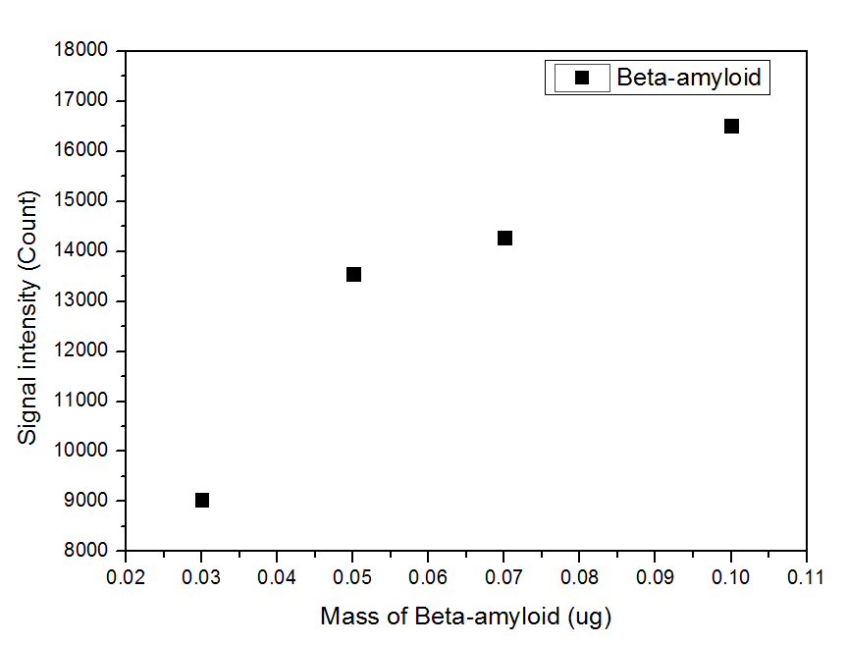
Fig. 1. Please put the title of figure here.(Times New Roman, 10, Line Height 1)

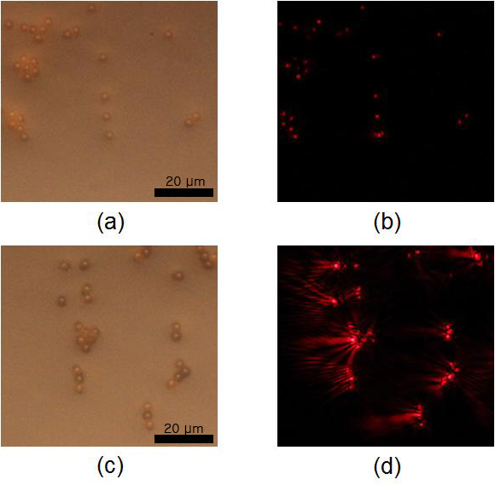
Fig. 2. Please put the title of figure here ; (a) Aaa, (b) Bbb, (c) Ccc, (d) Ddd.

수식 맨 끝에 번호를 기입하세요.

$\begin{aligned}\int{ F(r,ϕ)} \text{dr} dϕ=[{σr}_{2} (2μ_{0})] \\ ⋅ \int{ \text{exp}}(−λ|z_{j}−z_{i}| ) λ^{−1} J_{1}(λ r_{2}) J_{0}(λ r_{i}) dλ \text{.}\end{aligned}$(1)

결론(신명조, 11, 줄간격 1줄)

여기에 결론을 입력하세요. (신명조, 9, 줄간격 1줄)

감사의 글(신명조, 11, 줄간격 1줄)

여기에 감사의 글을 입력하세요. (신명조, 9, 줄간격 1줄)

REFERENCES(Time New Roman, 12, Line Height 1)

Write references here.(Time New Roman, 10, Line Height) 1) All references should be given in English.

A. In the case of journals: Names of the authors, “title”, name of the journal in italic type(ISO Abbrev. Title), volume number, page numbers and year published.

[1] T. Takalokastari, S. J. Jung, D. D. Lee, and W. Y. Chung, “Real time drowsiness detection by WSN based wearable ECG measurement system”, J. Sens. Sci. Technol., Vol. 20, No. 6, pp. 382-387, 2011.
[2] S. Troiler-McKinstry and P. Muralt, "Thin Film Piezoelectric for MEMS", J. Electroceram., Vol. 12, No. 1, pp. 7-17, 2004.

B. In the case of books: Names of the authors, name of the book in italic type, publishing company, place published, page numbers and year published.

Single Author
[1] W. K. Chen, Linear Networks and Systems, Belmont, Wadsworth Press, CA, pp. 180-182, 2003.

Edited Book
[2] J. L. Spudich and B. H. Satir, Eds., Sensory Receptors and Signal Transduction, Wiley-Liss, New York, pp. 180-182, 2001.

Selection in an Edited Book
[3] E. D. Lipson and B. D. Horwitz, “Photosensory reception and transduction,” in Sensory Receptors and Signal Transduction, J. L. Spudich and B. H. Satir, Eds. Wiley-Liss, New York, pp. 1-64, 2001.

Three or More Authors
[4] R. Hayes, G. Pisano, and S. Wheelwright, Operations, Strategy, and Technical Knowledge, Wiley, Hoboken, NJ, pp. 1-64, 2007.

Book by an Institutional or Organizational Author
[5] Council of Biology Editors, Scientific Style and Format: The CBE Manual for Authors, Editors, and Publishers, 6th ed., Cambridge University Press, Chicago, 2006.

C. In the case of conference papers: Names of the authors, “title”, name of the proceeding in italic type, page numbers, place, country and year published.

[1] W. G. Jeon and Y. S. Cho, “An equalization technique for OFDM and MC-CDMA in a multipath fading channels”, Proc. of IEEE Conf. on Acoust. Speech Signal Process., pp. 2529-2532, Munich, Germany, 1997.

D. In the case of web sites: URL, access date.

[1] http://www.sensors.or.kr/ (retrieved on Sep. 8, 2012).

E. In the case of patents and standards: Name of the inventors, “title”, Patent number, and filing date.

[1] K. Kimura and A. Lipeles, “Fuzzy controller component”, U. S. Patent 14, 860,040, 14 Dec., 2006.
[2] Accredited Standartds Committee S3, “Specification for audiometers”, ANSI/ASA S3.6, 01 Jan., 2010.

F. In the case of thesis or dissertation

[1] H. Zhang, “Delay-insensitive networks”, M. S. thesis, University of Chicago, Chicago, IL, 2007.

<참고사항>
Journal abbrevation는 하단 사이트 참고
- https://www.ncbi.nlm.nih.gov/nlmcatalog/journals
- http://www.issn.org/services/online-services/access-to-the-ltwa/

